DBS LAB 06:
24K-0810
Task 1 – Single Row Subquery
Write a query to display employee ID, first name, last name, and salary of
employees whose salary is greater than the average salary of all employees.
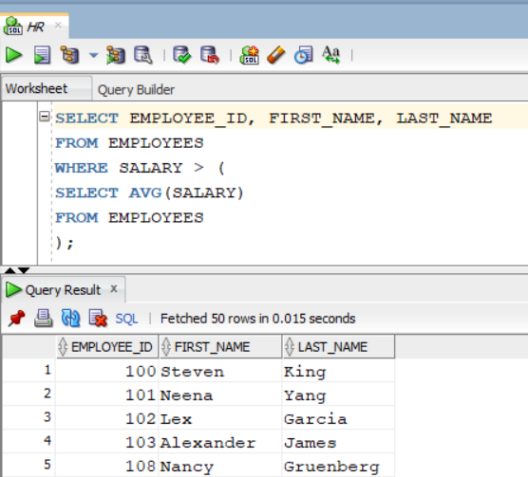

Task 2 – Single Row Subquery
Write a query to find the employee(s) who earn the minimum salary in the
employees table.
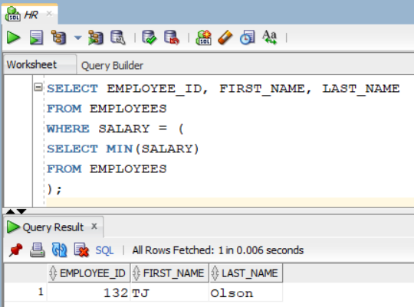

Task 3 – Multiple Row Subquery (IN Operator)
Write a query to display first name, last name, and department ID of employees
who work in departments located in location_id = 1700.
Hint: Use a subquery to retrieve department IDs from the departments table.
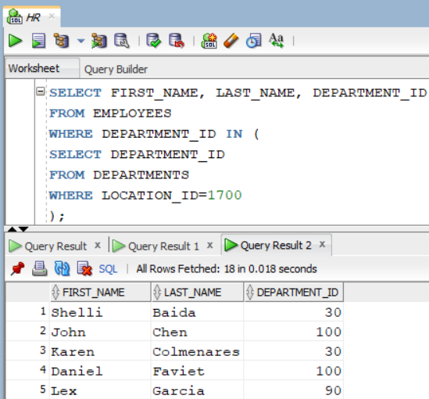

Task 4 – Correlated Subquery
Write a query to display employee ID, first name, salary, and department ID of
employees who earn more than the average salary of their own department.
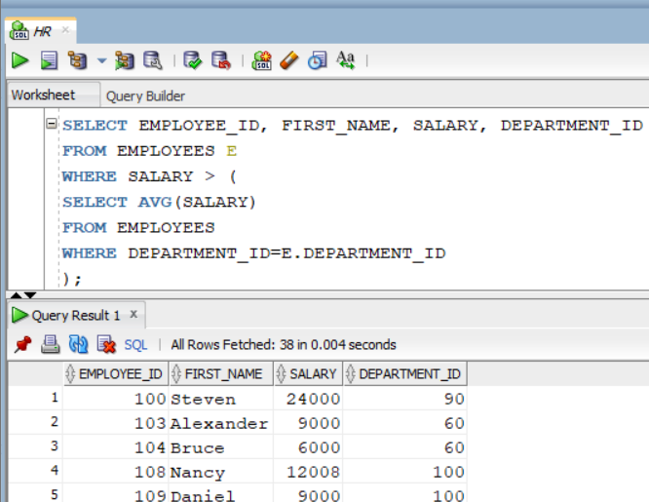

Task 5 – EXISTS Subquery
Write a query to display employee ID and first name of employees who are
managers (i.e., at least one employee reports to them).
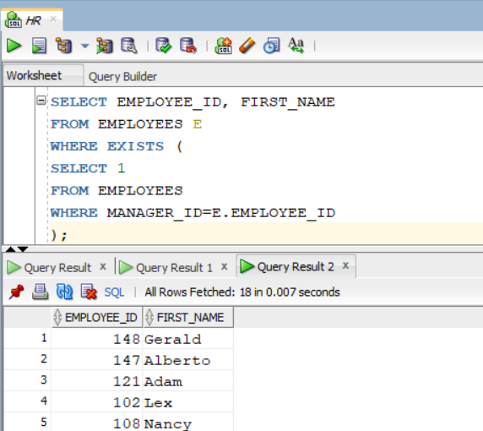

Task 6 – Inline View (Subquery in FROM)
Write a query to display department ID and average salary for departments
whose average salary is greater than 8000.
Hint: Use a subquery in the FROM clause and assign it an alias.
